**Technical Career Education Private Limited**

5th floor, Sahyadri Campus, Adyar, Mangalore 575007



**Hybrid Course on Embedded System**

**PROJECT REPORT**

**2023 - 24**

**Project Title: ‘Low-Cost Temperature and Humidity Monitoring System for Cold Storage’**

Submitted by:

|  |  |
| --- | --- |
| **Amrutha B** | **4SF22EC007** |
| **Apoorva Nagekar** | **4SF22EC010** |
| **Simran Shaikh** | **4SF22EC104** |

Institution:



**Sahyadri College of Engineering and Management**

Adyar Mangalore 575007

**CONTENTS**

**Project Overview**

1. **Introduction**

1. **Problem Statement**

**3. Solution**

3.1 Ideation

3.2 Prototype

**4. Conclusion**

**5. References**

**Project Overview**

|  |  |  |
| --- | --- | --- |
| Problem Statement | Low-Cost Temperature and Humidity Monitoring System for Cold Storage’ | |
| Working Prototype  *(Drive Video Link)* | <https://drive.google.com/drive/folders/17It71gAxzJTwfwBw84Xhq-d5z96jjXg3?usp=sharing> | |
| Final Presentation *(Link)* | <https://drive.google.com/drive/folders/17It71gAxzJTwfwBw84Xhq-d5z96jjXg3?usp=drive_link> | |
| Relevant Photos/ Media  *(Drive Folder Link)* | <https://drive.google.com/drive/folders/13m4Xzx-gWKf0MCZjonHEf9HT74BQ5HNa?usp=sharing> | |
| Class/ Section | 6sem/A | |
| Team Members | Name | USN |
| Amrutha B | 4SF22EC007 |
| Apoorva Nagekar | 4SF22EC010 |
| Simran Shaikh | 4SF22EC104 |

1. **Introduction**

In today’s food supply chain and pharmaceutical industries, maintaining precise temperature and humidity conditions is crucial to prevent spoilage, ensure product quality, and comply with regulatory standards. Cold storage units play a vital role by offering controlled environments for storing perishable items. However, conventional monitoring systems in these setups are often costly, require manual supervision, and lack secure access control. This highlights the need for an efficient, automated, and cost-effective solution—particularly for small-scale vendors and rural storage facilities.

This project presents a low-cost, enhanced temperature and humidity monitoring system tailored for cold storage applications, leveraging the STM32F401RE microcontroller. The system incorporates a DHT22 sensor for measuring environmental parameters and an OLED display for real-time data visualization. To strengthen security and access tracking, an RFID module is integrated to log the identity and entry times of individuals accessing the cold room.

The system is developed using HAL-based Embedded C and utilizes I2C, UART, and GPIO peripherals to interface the components effectively. Beyond simple monitoring, the system includes a relay control mechanism to automate responses—such as activating a dehumidifier—when humidity exceeds defined thresholds. High-speed I2C communication ensures fast and stable data transmission to the OLED screen, providing immediate feedback for on-site users. Additionally, timer-based microDelays are employed for precise timing control, which is critical for accurate DHT22 sensor readings.

These improvements not only enhance the system’s reliability and responsiveness but also illustrate the potential of affordable, professional-grade embedded systems in addressing real-world challenges. By offering a practical balance between cost, precision, and automation, this project bridges the gap between basic manual solutions and expensive industrial-grade systems.

1. **Problem Statement**

Cold storage facilities are essential for preserving perishable goods such as dairy products, seafood, fresh produce, and vaccines. However, small-scale operators in rural and semi-urban regions often face challenges in adopting commercial-grade monitoring and automation systems due to their high cost and technical complexity. As a result, many rely on manual monitoring methods, which can lead to issues such as inaccurate data, human error, and limited traceability. Additionally, unauthorized access to these facilities can compromise hygiene standards and affect the quality of stored products.

To overcome these challenges, this project introduces a smart embedded monitoring system built around the STM32F401RE microcontroller, recognized for its performance and scalability. The system integrates a DHT22 sensor for real-time temperature and humidity measurement, an OLED screen for on-site data display, and an RFID reader for secure and logged access control. In this enhanced version, GPIO configurations have been optimized using STM32CubeMX-generated pin mappings based on the chip diagram, ensuring precise peripheral integration. Programming is carried out using HAL libraries, offering improved hardware abstraction and system stability.

This solution provides a modular, dependable, and cost-effective platform for small-scale cold storage operators aiming to digitize and automate their facility management without the need for complex infrastructure.

1. **Solution**

This advanced cold storage monitoring system is built around the STM32F401RE microcontroller to deliver efficient performance, precise sensor readings, and dependable control operations. The system is organized into three main functional modules:

1. **Environmental Sensing Module** – A DHT22 sensor continuously monitors the internal temperature and humidity of the cold storage environment, ensuring real-time data collection.
2. **Display and User Feedback** – An OLED display presents live environmental readings, allowing on-site users and technicians to quickly verify storage conditions.
3. **Access Control and Automation** – An RFID module is integrated for secure access tracking and control. It is connected via the SPI interface, utilizing pins PC0–PC3 and PB10 for communication with the microcontroller.

**3.1 Ideation**

The concept for this project originated from the need for a cold storage monitoring system that goes beyond simply measuring environmental parameters. The goal was to develop an integrated solution that enhances security through RFID-based access control, offers real-time data visibility via an OLED display, and enables automation through relay-based control.

**Core objectives during the ideation phase:**

* Ensure **accurate, real-time monitoring** of temperature and humidity.
* Provide **live data visualization** on a compact OLED screen.
* Enable **automated control** using a relay when humidity levels exceed predefined safety thresholds.
* Incorporate **RFID-based authentication** to restrict access and enhance system security.
* Maintain **cost-effectiveness** and **ease of deployment**, particularly for small-scale or non-industrial users.

**3.2 Prototype**

We developed a fully functional prototype using cost-effective and readily available components to create an intelligent cold storage monitoring system. This design utilizes the STM32F401RE microcontroller, chosen for its precision, performance, and peripheral support. The solution seamlessly integrates environmental monitoring, secure RFID-based access control, real-time OLED display, and automated response capabilities. This makes it not only suitable for real-world deployment but also technically strong enough for academic and industrial demonstrations.

**System Workflow:**

1. **RFID module** verifies and logs authorized personnel access.
2. **DHT22 sensor** captures real-time temperature and humidity readings.
3. **OLED display** provides instant visual feedback of environmental conditions.
4. **Optional buzzer or LED indicators** alert users to abnormal conditions.
5. **Relay control** automatically activates connected devices (e.g., dehumidifiers) when humidity exceeds the 60% threshold.

|  |  |  |
| --- | --- | --- |
| **Component** | **Functionality** | **Pin Connection (STM32F401RE)** |
| **DHT22 Sensor** | Measures temperature and humidity | DATA – **PB8** |
| **OLED Display** | Displays temperature, humidity, and RFID status | SCL – **PB6**  SDA – **PB7** |
| **RFID Reader** | Detects RFID tags and verifies authorized access | SCK – **PB10**  MISO – **PC2**  MOSI – **PC3**  SS (NSS) – **PC1**  RST – **PC0** |

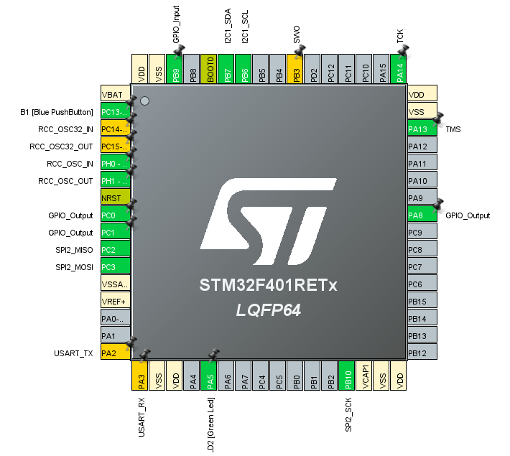

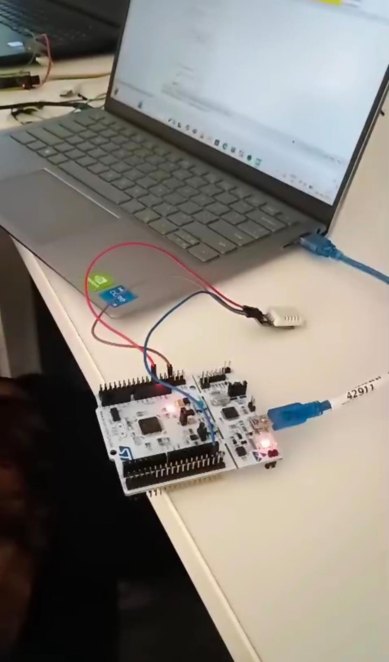

1. **Conclusion**

The **Affordable Cold Storage Monitoring System** efficiently integrates automated sensing, secure access verification, and responsive control in a compact, cost-effective design. It highlights the potential of the STM32F401RE microcontroller, paired with precise sensors and well-structured GPIO mapping, to deliver essential features found in high-end industrial systems—without the associated expenses.

Utilizing the DHT22 sensor for accurate temperature and humidity readings, an OLED display for real-time feedback, and a relay mechanism for automated responses, the system promotes operational reliability and protection for sensitive goods. Development through STM32CubeIDE and HAL libraries ensures code stability, modular design, and the flexibility to incorporate advanced features such as remote alerts or cloud-based dashboards in the future.

This solution is especially suitable for small cold storage setups, rural storage units, and academic environments aiming to digitize manual systems while keeping costs minimal.